How to Tackle the First Book Report Summary
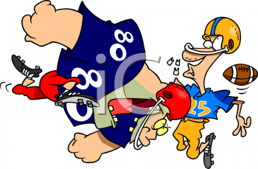
The most common mistake students make is leaving out one of the 5 main elements of the summary. Here is the breakdown of the elements.
- Setting
Here are questions to get you thinking about the setting:
- When did the story take place?
- Where did the story take place?
- Is there more than one setting?
- Describe the location/s in as much detail as you can.
- If the book doesn't explicitly state dates and time periods, what can you gather from the details of the book to give you hints about when and where the story takes place?
Copy and paste your settings practice here.

- Characters
Introduce your readers to the main characters in the story. Try to give your audience an idea about the personality of your main characters as well as their physical attributes (how do they act or behave and how do they look.)
Copy and paste your character descriptions here.

- Plot
This may seem like a daunting task, but let’s simplify it. (If you’ve been writing each night about your book, these notes can be used to help you review and remember the story.)
Start by writing down the five or six main events of the story. Write them in order (bullet format—no need for complete sentences here). You can use this like an outline for writing the summary.

Take one event at a time and tell about it. Develop one paragraph about these events. Be careful not to include every detail in the story. Your goal is to summarize the plot of the story in about a half of a page.

Copy and paste your plot summary here.

- Moral/Theme

Here is a refresher on the concept of a book’s theme:

A good definition of a theme (in the context of your book report requirement) can be found in Wikipedia:
A theme is a broad idea, message, or moral of a story. The message may be about life, society, or human nature. Themes often explore timeless and universal ideas and are almost always implied rather than stated explicitly. Along with plot, character, setting, and style, theme is considered one of the fundamental components of fiction.
Remember, a theme is NOT referring the genre (e.g., mystery). Think about hidden messages you picked up on in the story; themes are not usually stated in the story.
Copy and paste your themes practice here.

- Critique
The last element is your critique of the book. I am looking for more than a mere recommendation. In other words, this statement won’t work:
“I really liked the book, and I would recommend to other kids my age.”

Your critique needs to include the strengths as well as the weaknesses of the book. Give me specifics. For example, rather than telling me you liked the author’s style of writing, describe the style and why it appealed to you. If you truly can’t find a weakness for a particular book, make sure you tell me more about why this book was so terrific.

Copy and paste your critique here.

When you have completed this guide, you’ll be ready to score a touchdown! All you need to do is copy and paste all of the elements when they are finished in this order on a separate document, and you’re finished
